**MICROPROJECT REPORT**

**Java Programming (314317)**

**TOPIC: GUI-Based Temperature Tracker**

1. **RATIONALE:**

In today's fast-paced world, temperature monitoring plays a crucial role in various domains, including healthcare, agriculture, environmental monitoring, and industrial applications. A **GUI-Based Temperature Tracker** provides a user-friendly interface to record, display, and analyze temperature variations efficiently.

1. **AIMS AND BENEFITS OF THE MICROPROJECT:**
2. **Real-time Monitoring:** Enables users to track temperature changes over time.
3. **User-Friendly Interface:** Provides an intuitive GUI for easy interaction and data visualization.
4. **Data Logging & Analysis:** Stores past temperature data for trend analysis and future reference.
5. **Multi-source Input:** Can fetch temperature data from user input, APIs (e.g., OpenWeatherMap), or sensors.
6. **COURSE OUTCOMES ADDRESSES:**

* CO1: Develop Java Program using classes and objects.
* CO2: Develop Java Program for implementing code reusability concept.
* CO3: Develop Java Program to implement multithreading and exception handling.
* CO4: Develop Java Program for implementing event-handling using window-based application components.

1. **ACTUAL METHODOLOGY FOLLOWED**
2. Systematic Approach to Development
3. Structured Methodology for Implementation
4. Phased Development Strategy
5. Design and Implementation Framework
6. Development Lifecycle and Workflow
7. Step-by-Step Process for System Development
8. Methodical Approach to System Design
9. Software Development Methodology
10. Implementation Strategy and Workflow
11. Process Model for Application Development

**5.0 Actual resources used:**

|  |  |  |  |
| --- | --- | --- | --- |
| **Sr. no** | **Name of resources / material** | **Specifications** | **Qty** |
| **1.** | Personal computer | Windows 11 with suitable software | 02 |
| **2.** | Java Sorftware | Jdk 1.8.321 | 01 |

1. **Code :**

import javax.swing.*;*

import java.awt.;

import java.awt.event.*;

public class TempTrackerGUI extends JFrame implements ActionListener { JTextField tempFields[] = new JTextField[7]; JButton calculateButton; JLabel resultLabel;

TempTrackerGUI() {  
 setTitle("Temperature Tracker");  
 setSize(450, 450);  
 setDefaultCloseOperation(JFrame.EXIT_ON_CLOSE);  
 setLayout(new BorderLayout(10, 10));  
  
 JLabel instruction = new JLabel("Enter temperatures for 7 days:", SwingConstants.CENTER);  
 add(instruction, BorderLayout.NORTH);  
  
 JPanel inputPanel = new JPanel(new GridLayout(7, 2, 5, 5));  
 for (int i = 0; i < 7; i++) {  
 inputPanel.add(new JLabel("Day " + (i + 1) + ":"));  
 tempFields[i] = new JTextField();  
 inputPanel.add(tempFields[i]);  
 }  
 add(inputPanel, BorderLayout.CENTER);  
  
 calculateButton = new JButton("Calculate");  
 resultLabel = new JLabel("", SwingConstants.CENTER);  
 calculateButton.addActionListener(this);  
  
 JPanel bottomPanel = new JPanel(new GridLayout(2, 1, 5, 5));  
 bottomPanel.add(calculateButton);  
 bottomPanel.add(resultLabel);  
 add(bottomPanel, BorderLayout.SOUTH);  
  
 setVisible(true);  
}  
  
public void actionPerformed(ActionEvent e) {  
 float sum = 0, max, min;  
 int maxDay = 0, minDay = 0;  
 float[] temperatures = new float[7];  
  
 for (int i = 0; i < 7; i++) {  
 try {  
 temperatures[i] = Float.parseFloat(tempFields[i].getText());  
 sum += temperatures[i];  
 } catch (NumberFormatException ex) {  
 resultLabel.setText("Enter valid numbers!");  
 return;  
 }  
 }  
  
 float avg = sum / 7;  
 max = min = temperatures[0];  
  
 for (int i = 1; i < 7; i++) {  
 if (temperatures[i] > max) {  
 max = temperatures[i];  
 maxDay = i;  
 }  
 if (temperatures[i] < min) {  
 min = temperatures[i];  
 minDay = i;  
 }  
 }  
  
 resultLabel.setText("Average: " + avg + " | Maximum: " + max + " (Day " + (maxDay + 1) + ")" +  
 " | Minimum: " + min + " (Day " + (minDay + 1) + ")");  
}  
  
public static void main(String args[]) {  
 new TempTrackerGUI();  
}

}

1. **Output:**

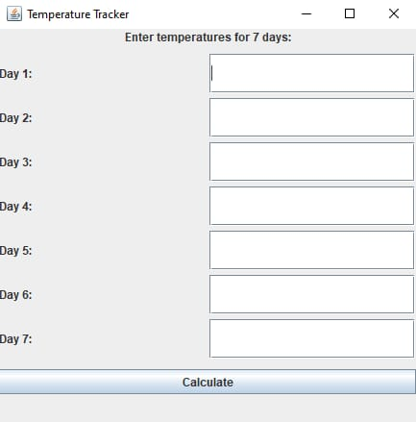

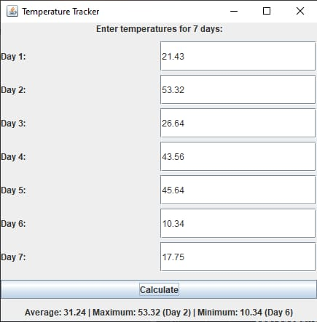

**Note:** Output when characters or anything else than integers/float values are entered

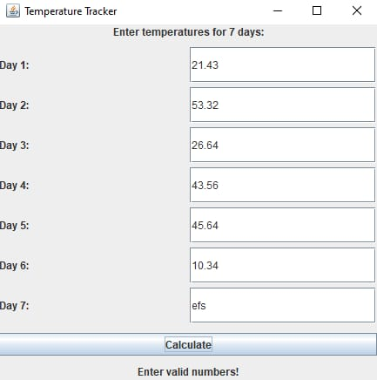

**8.0 Skills developed**

Through the completion of this microproject, we were able to enhance our skills in the following areas:

* GUI Development with Java Swing
* Exception Handling and Error Management
* Data Processing and Logical Thinking
* Problem-Solving and Debugging
* Software Development Lifecycle (SDLC) Understanding
* UI/UX Design Considerations

**9.0 Application of Micro project**

* Personal Temperature Logging
* Weather Analysis
* Healthcare Monitoring
* Agriculture & Farming
* Industrial Use